PROJECT REPORT
Customer Satisfaction Report for E-commerce Business

Subject: Office Automation Lab
Section: 26BCA4A

Name | UID
Khushi Naskar | 26BCA10196
Pranjali Choudhary | 26BCA10187
Project Title: Customer Satisfaction Report for E-commerce Business
Reference Case Study: Flipkart (India’s leading e-commerce marketplace)
Technologies Used: Microsoft Excel, Microsoft Word, Google Forms

Table of Contents
1. Abstract
2. Demo and Code
3. Project Objectives
4. Technologies Implemented
5. Project Features
6. Development Process
7. Conclusion

1. Abstract
In today's competitive online market, a business cannot grow only by selling products; it must also keep its customers happy. Satisfied customers return, recommend the store to others and write positive reviews, while dissatisfied customers leave quietly and often share their bad experience. Understanding how customers feel is therefore a practical business need and not just an academic exercise.
This project studies customer satisfaction for an online retail store. Feedback was collected from online shoppers through a structured questionnaire created in Google Forms. It covered product quality, website usability, pricing, delivery, packaging, customer support and the return process, along with open-ended comments. The responses were exported to Microsoft Excel, cleaned, and analysed using formulas, pivot tables and charts. The final findings were written in Microsoft Word.
To make the study realistic, Flipkart, one of India’s largest e-commerce platforms, was used as a reference: its publicly available complaint data and customer reviews were compared with the survey results. The analysis shows that customers are generally satisfied with product quality and the ease of using the website, but are unhappy with delivery speed, packaging, customer support and the return and refund process. About two-thirds of the respondents were satisfied overall. The report ends with practical, prioritised recommendations that the business can follow to improve the shopping experience.
2. Demo and Code
This is an Office Automation project, so it has no hosted website or program code. The “demo” is the Excel workbook in which the data was processed, together with this Word report. The workbook contains the raw survey sheet, a cleaned data sheet, a summary sheet with calculations, pivot tables and charts.
2.1 Overall Workflow
Stage | Activity | Tool
1 | Design the questionnaire and collect responses | Google Forms
2 | Export the responses and clean the data | Excel (Remove Duplicates, Filters, Find & Replace)
3 | Calculate averages and percentages | Excel formulas
4 | Summarise and compare using pivot tables | Excel PivotTables
5 | Create charts and highlight weak areas | Excel Charts, Conditional Formatting
6 | Write and format the final report | Microsoft Word
Table 1: Workflow of the project
2.2 Excel Formulas Used
The following formulas were used in the workbook to automate the calculations. Because they are formula-driven, the results update automatically whenever new responses are added.
Formula | Purpose
=AVERAGE(range) | Average rating of each parameter
=COUNT(range) | Number of valid responses
=COUNTIF(range,">=4") | Number of satisfied customers (rating 4 or 5)
=COUNTIF(range,"<=2") | Number of dissatisfied customers (rating 1 or 2)
=COUNTIF(range,"<=2")/COUNT(range) | Percentage of dissatisfied customers
=IF(avg>=4,"Strong",IF(avg>=3.5,"Good","Needs improvement")) | Automatic remark for each parameter
=RANK(cell,range) | Ranking of parameters from best to worst
Table 2: Main Excel formulas used
2.3 Screenshots (Illustrative Mock-ups)
Figure 1 shows the layout of the survey form and Figure 2 shows the summary sheet and chart in Excel. These are illustrative mock-ups; the original screenshots of the form and workbook can be placed here.
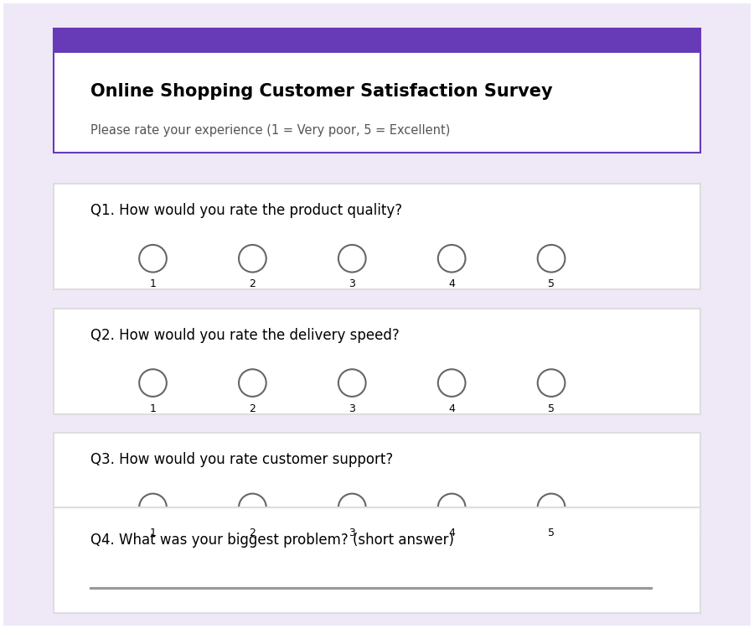
Figure 1: Survey form layout (Google Forms mock-up)
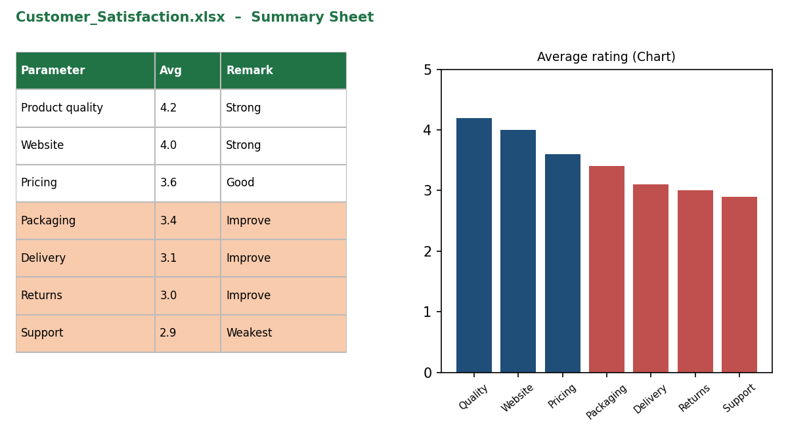
Figure 2: Excel summary sheet with conditional formatting and chart (mock-up)
3. Project Objectives
The main aim of the project is to find out how satisfied customers are with an online retail store and why. This broad aim was divided into the following specific objectives.
- To measure satisfaction: calculate the overall satisfaction level of customers on a 1–5 rating scale and express it as a percentage of satisfied, neutral and dissatisfied customers.
- To analyse each part of the experience: examine product quality, website usability, pricing, delivery, packaging, support and returns separately, so that the strong and weak areas are clearly visible.
- To identify pain points: study the open-ended comments to find the problems customers face most often.
- To recommend improvements: suggest realistic, prioritised actions that the business can implement.
- To benchmark against Flipkart: compare the survey findings with publicly reported complaints about Flipkart to check whether the same problems appear in a large, well-known marketplace.
- To apply Office Automation skills: use Excel and Word on a real business problem, including data cleaning, formulas, pivot tables, charts and professional document formatting.
4. Technologies Implemented
4.1 Google Forms
Google Forms was used to create and distribute the survey. It supports rating scales, multiple-choice questions and short text answers, and it records every response automatically in a spreadsheet. Being free and mobile-friendly, it let respondents answer within two to three minutes from their phones, which improved the response rate.
4.2 Microsoft Excel
Excel was the main analysis tool. The raw responses were imported and cleaned using filters and the Remove Duplicates feature. Formulas such as AVERAGE, COUNTIF and IF were used to compute the results. PivotTables were used to summarise the data by parameter and by respondent group, such as age and shopping frequency. Bar and pie charts presented the results visually, and Conditional Formatting coloured low-rated parameters in red so that weak areas were obvious at a glance.
4.3 Microsoft Word
Word was used to prepare this report. Features used include heading styles, a cover page, tables with captions, inserted charts, bullet lists, page numbers and consistent formatting. These help the reader move through the report easily and give it a professional appearance.
5. Project Features
The project has several features that together convert raw customer opinions into useful business information. Each feature is explained below with the corresponding results.
5.1 Structured Survey
The questionnaire had four parts: a short respondent profile, ratings on seven aspects of the shopping experience, an overall satisfaction rating with a “would you recommend us?” question, and an open-ended question asking customers to describe their biggest problem. Using a common 1–5 scale made the answers easy to compare.
Part | Content
A. Profile | Age group, shopping frequency, typical order value
B. Ratings (1–5) | Product quality, website ease of use, pricing and offers, delivery speed, packaging, customer support, returns and refunds
C. Overall | Overall satisfaction rating; likelihood to recommend the store (Yes / Maybe / No)
D. Open-ended | “What was the biggest problem you faced while shopping with us?”
Table 3: Structure of the questionnaire
5.2 Respondent Profile
Fifty respondents took part. Most were between 18 and 25 years old, which matches the typical online shopper group of students and young professionals. More than half shopped online at least once a month.
Age Group | Respondents | Shopping Frequency | Respondents
Below 18 | 3 | Weekly | 11
18–25 | 32 | Monthly | 18
26–35 | 11 | Occasionally | 16
Above 35 | 4 | Rarely | 5
Table 4: Respondent profile (n = 50)
5.3 Rating Analysis
The average rating of every parameter was calculated using Excel formulas and is shown in Table 5 and Figure 3. Product quality received the highest rating, followed by the website. Customer support received the lowest rating.
Parameter | Average (out of 5) | Remark
Product quality | 4.2 | Strong
Website ease of use | 4.0 | Strong
Pricing and offers | 3.6 | Good
Packaging | 3.4 | Needs improvement
Delivery speed | 3.1 | Needs improvement
Returns and refunds | 3.0 | Needs improvement
Customer support | 2.9 | Weakest area
Table 5: Average rating of each parameter
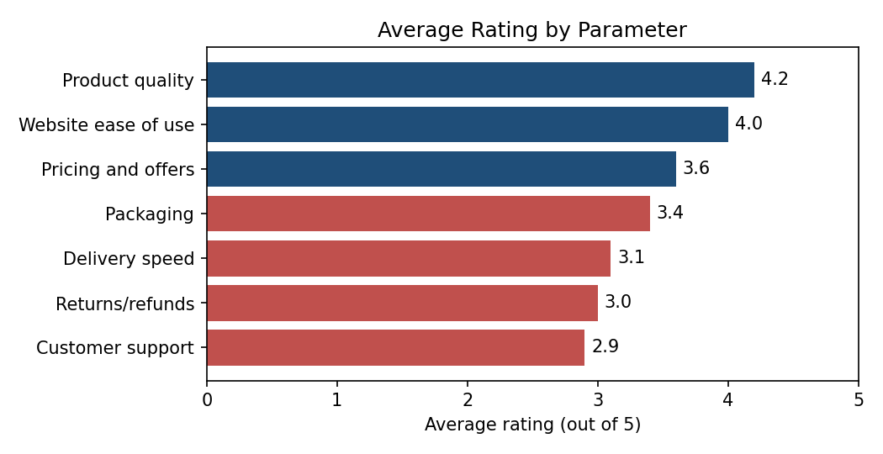
Figure 3: Average rating by parameter (red bars indicate ratings below 3.5)
5.4 Overall Satisfaction
Out of the fifty responses, 34 customers (68%) gave an overall rating of 4 or 5 and were counted as satisfied. Another 8 customers (16%) gave a rating of 3 and 8 customers (16%) gave a rating of 1 or 2. When asked whether they would recommend the store to friends, 58% said yes, 30% said maybe and 12% said no. This means that satisfaction is good but not strong enough to guarantee loyalty.
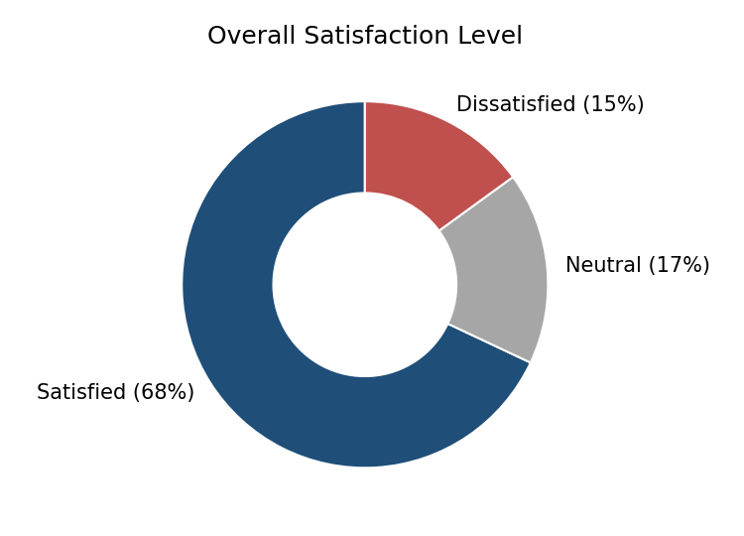
Figure 4: Overall customer satisfaction
5.5 Pain-Point Analysis
The open-ended answers were read carefully and grouped into themes. Counting how many times each theme appeared showed which problems are most widespread. Late delivery was the most common complaint, followed by slow or unhelpful customer support and damaged or poor packaging.
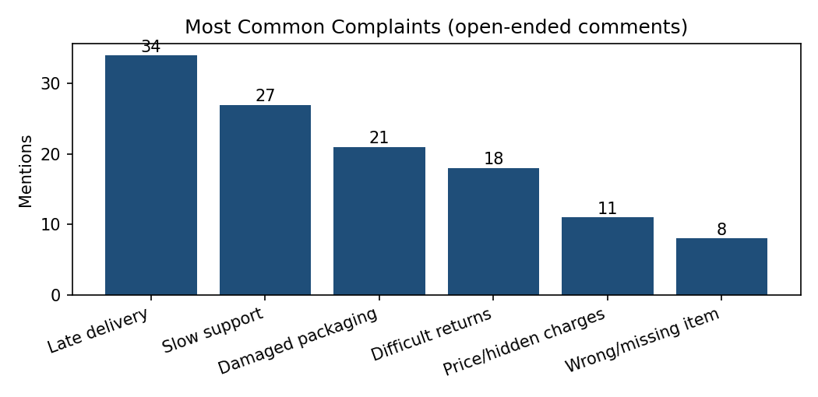
Figure 5: Most common complaints from customer comments
Pain Point | What Customers Said | Impact
Late delivery | Orders arrive after the promised date; tracking is not updated | Loss of trust, cancelled orders
Slow support | Emails and calls take days to get a reply; answers are generic | Unresolved problems, frustration
Poor packaging | Boxes are crushed; items are loosely packed | Damaged products, returns
Difficult returns | Return approval and refunds take too long | Customers avoid buying again
Hidden charges | Delivery or handling fees appear only at checkout | Cart abandonment
Table 7: Summary of main pain points
5.6 Reference Case Study: Flipkart
Flipkart, a leading Indian online marketplace, was chosen as the reference platform because most respondents were familiar with it and it publishes a large amount of public feedback. Two sources were used: the grievance statistics of the National Consumer Helpline (consumerhelpline.gov.in) and public customer reviews on platforms such as Trustpilot.
Complaint data. The National Consumer Helpline reports the grievances received against Flipkart between 1 January and 19 July 2025. The largest category was delivery of defective or damaged products (9,243), followed by customer-service deficiencies (6,179), replacement or refund not provided (5,481), non-delivery (4,728), wrong product delivered (4,436), delay in delivery (4,099) and paid amount not refunded (3,787). News reports citing figures given in the Lok Sabha also state that Flipkart received over 1.33 lakh complaints through the helpline in the last reported year, the highest among e-commerce platforms, and that non-delivery was the biggest source of consumer frustration across all platforms.
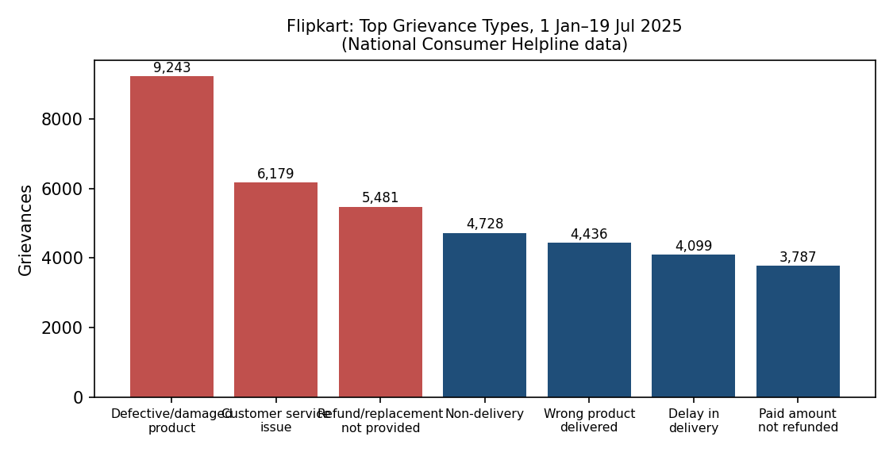
Figure 6: Top grievance types against Flipkart (data: National Consumer Helpline, 2025)
Customer reviews. Public reviews on Trustpilot mention recurring themes: refund or return requests being rejected, complaints closed without proper investigation, delivery problems involving courier partners, and difficulty reaching customer support. Positive points usually relate to product range, offers and the convenience of the app.
It should be noted that Flipkart handles a very large volume of orders, so a high number of complaints does not by itself mean a high complaint rate, and online reviews tend to come more from unhappy customers. The data is therefore used only to compare the types of problems, not to rank the company.
Parameter | Our Survey | Flipkart (Public Data)
Product quality | Highest rated (4.2) | Defective or damaged products form the largest grievance category
Delivery | Rated 3.1; late delivery was the top complaint | Non-delivery and delay are among the leading grievances
Customer support | Weakest area (2.9) | Customer-service deficiency is the second-largest grievance
Returns and refunds | Rated 3.0; slow and difficult | Refund or replacement not provided and unpaid refunds are frequent
Packaging | Rated 3.4; damaged boxes | Damaged and missing-item complaints are reported
Table 6: Comparison of survey findings with Flipkart public data
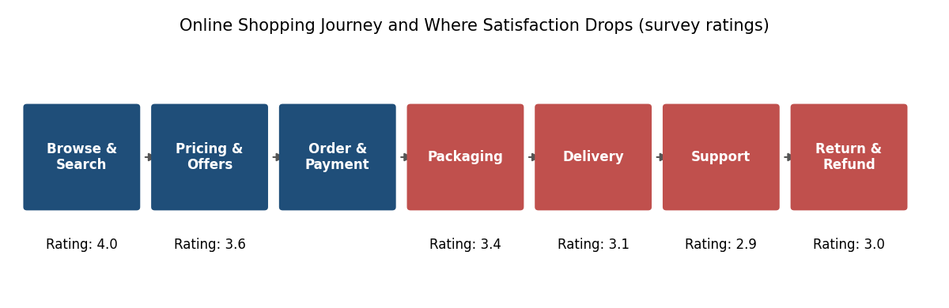
Figure 7: Shopping journey and average satisfaction at each stage
Observation. The pain points in our survey match those reported for a major marketplace. This suggests that the weak areas are not limited to a small store but are common across Indian e-commerce, and that after-sales service (delivery, support and refunds) is where most platforms lose customer trust. Flipkart’s own return policy, which offers exchange, replacement or refund after pick-up from the customer’s address and open-box delivery for some products, shows that clear and simple return rules are an important feature that smaller stores should also offer.
5.7 Areas of Improvement and Recommendations
Based on the ratings and comments, the following improvements are recommended. They are arranged by priority, with the weakest and most frequently mentioned areas first.
No. | Area | Recommended Action | Priority
1 | Customer support | Add live chat and a chatbot for common questions; promise a reply within 24 hours; train staff to solve problems on the first contact | High
2 | Delivery | Work with faster and more reliable courier partners; provide accurate delivery dates and real-time tracking | High
3 | Returns and refunds | Offer a simple one-click return request; process refunds within 5–7 working days | High
4 | Packaging | Use sturdier boxes and protective material for fragile items; check packing quality before dispatch | Medium
5 | Pricing transparency | Show all delivery and handling charges on the product page, not only at checkout | Medium
6 | Feedback | Send a short feedback form after every delivery and review the results every month | Ongoing
Table 8: Recommended improvements
6. Development Process
The project was completed in six steps, described below.
Step 1: Planning
We first decided what to measure and studied Flipkart’s public complaint data and reviews to understand which problems customers of large platforms usually report. After discussing common problems in online shopping, we chose seven parameters that cover the whole journey from browsing the website to receiving the product and returning it. We also decided to use a simple 1–5 scale so that the data could be analysed easily.
Step 2: Data Collection
The questionnaire was prepared in Google Forms and shared through messaging apps with classmates, friends, family members and other regular online shoppers. Responses were collected over about one week. The form was kept short so that people would complete it, and fifty responses were received.
Step 3: Data Cleaning
The responses were exported to Excel. Duplicate entries were removed, incomplete answers were checked, and inconsistent text, such as different spellings of the same answer, was corrected with Find and Replace. Filters were used to confirm that all ratings were between 1 and 5. Only the cleaned sheet was used for analysis, and the raw sheet was kept unchanged for reference.
Step 4: Analysis
Formulas calculated the average rating and the satisfaction percentages. PivotTables compared the ratings across parameters and respondent groups. We observed, for example, that frequent shoppers were more critical of delivery delays, since they experience them more often. Charts were then created to present the results visually.
Step 5: Interpretation
The comments were read and grouped into themes, and the number of mentions of each theme was counted. By combining low ratings with high complaint counts, we identified the real pain points and decided the priority of each improvement.
Step 6: Report Preparation
Finally, the results, charts and recommendations were organised in Word using headings, tables and captions. The report was reviewed for clarity, spelling and consistent formatting.
Challenges Faced
- Getting responses: some people did not reply to the first request, so the form was shared again and kept short.
- Interpreting comments: comments were written in different styles, so careful reading was needed to group them correctly.
- Presenting data clearly: choosing the right chart type and colours took trial and adjustment so that the charts were easy to understand.
Skills Learned
Through this project we improved our understanding of survey design, data cleaning, Excel formulas, PivotTables and charts, and we learned how to present data-based findings in a clear and professional Word report.
7. Conclusion
This project analysed customer satisfaction for an e-commerce business using survey data processed in Excel and presented in Word. The results show that the store succeeds in offering good products and an easy-to-use website, with about 68% of customers satisfied overall. However, weaknesses in customer support, delivery, packaging and the returns process reduce the overall experience and could cause customers to shop elsewhere.
The main lesson is that customer satisfaction depends on the complete experience, not only on the product. A business that improves its after-sales service — faster delivery, helpful support, careful packaging and easy returns — is likely to see higher loyalty, more repeat purchases and better reviews.
Limitations
The survey had a small sample of fifty respondents, mostly young people, and relied on voluntary answers, so the results may not represent all customers of the store.
Future Scope
The study can be extended by collecting responses from a larger and more varied group, repeating the survey every few months to measure progress, and building an Excel dashboard that updates automatically as new feedback arrives.
The comparison with Flipkart showed that the same issues — delivery, support and refunds — affect even the largest platforms, so these areas deserve special attention from any online seller.
Overall, the project met its objectives and gave us practical experience of using Office Automation tools to solve a real business problem.
References
- National Consumer Helpline, Government of India – Flipkart grievance dashboard (consumerhelpline.gov.in), data for 1 Jan–19 Jul 2025.
- News report on consumer complaints against e-commerce platforms, citing figures given in the Lok Sabha (Madhyamam, 2026).
- Public customer reviews of Flipkart on Trustpilot (2026).
- Flipkart return, replacement and refund policy information (Flipkart website and consumer guides).

